Julio Barros

Web Application Attacks and Countermeasures

Which tool did you use to crack the ftp credentials? Provide a screenshot.
Using hydra and the usernames / passwords txt I was able to find the ftp credentials.
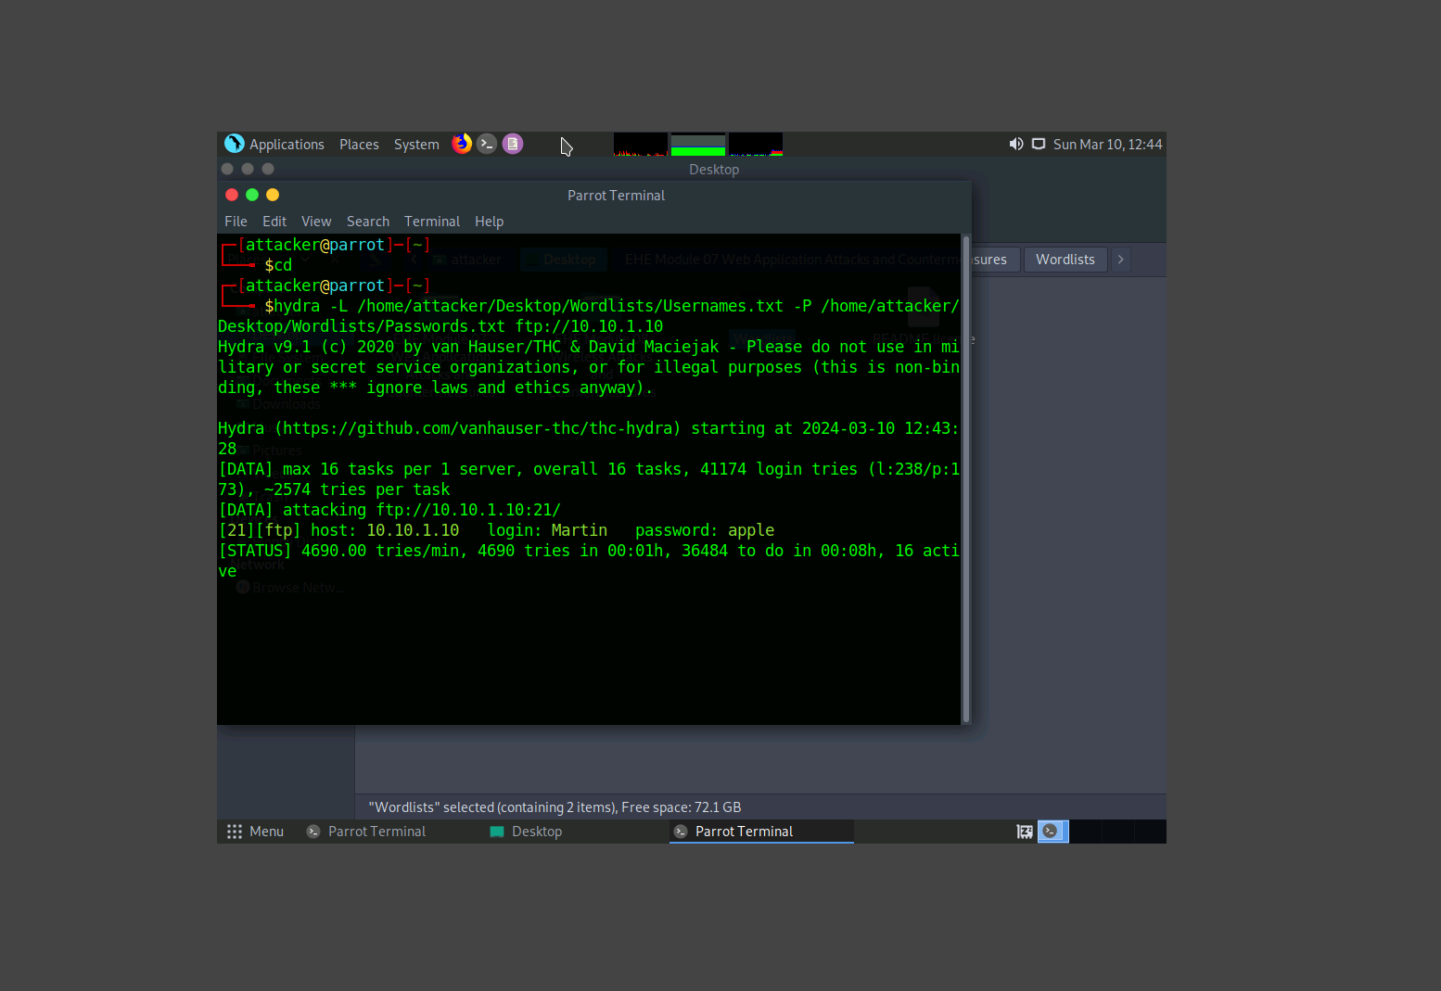
Provide a screenshot showing your parameter tampering efforts.
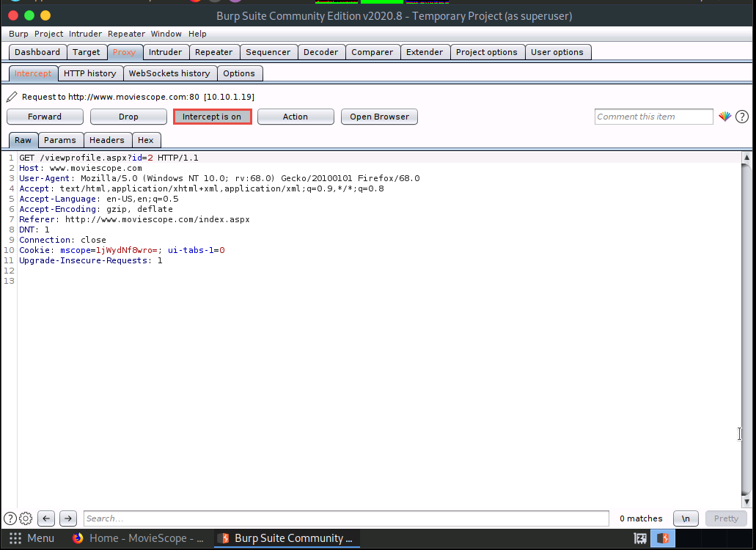

Provide a screenshot showing SQL injection results.
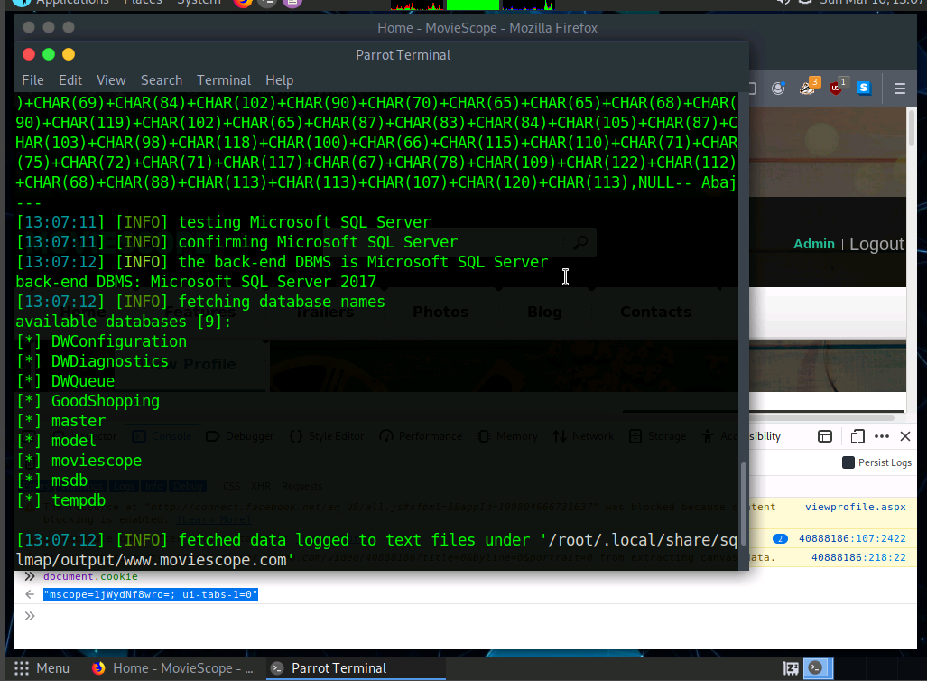
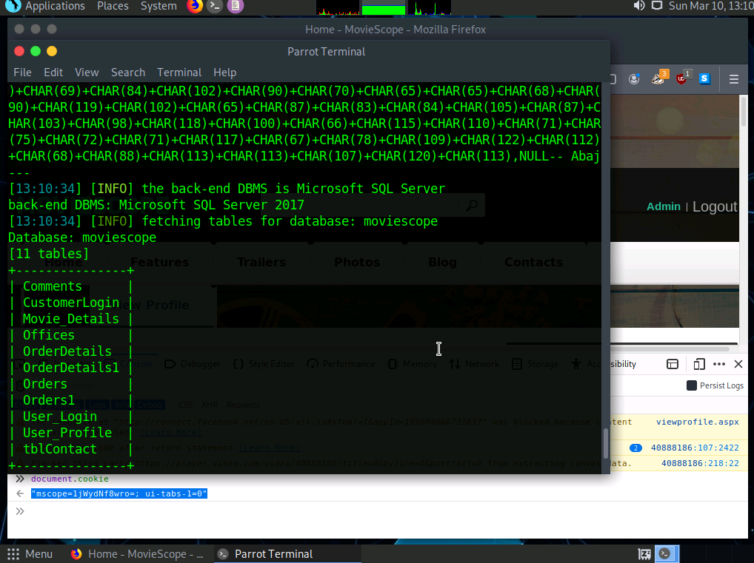
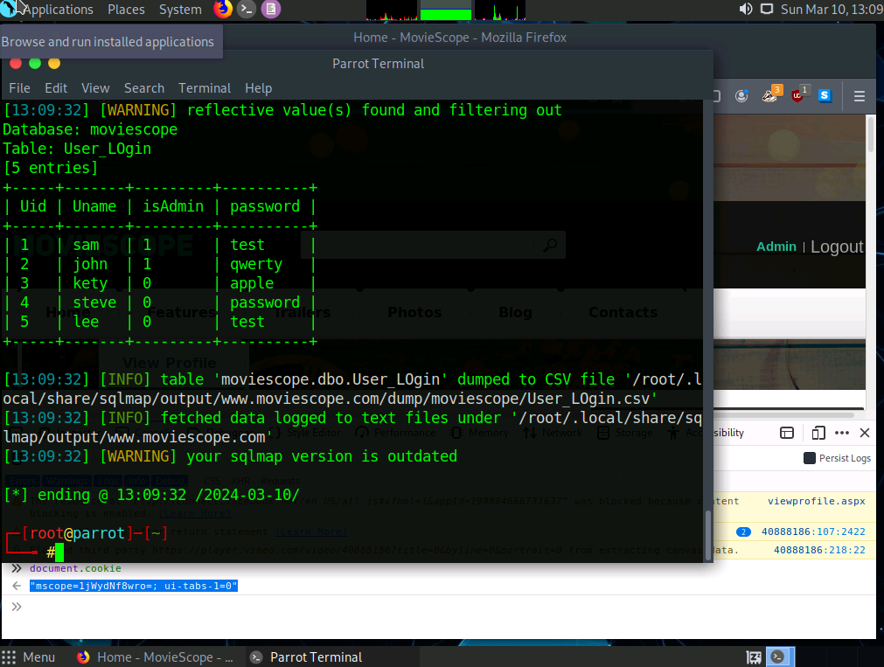
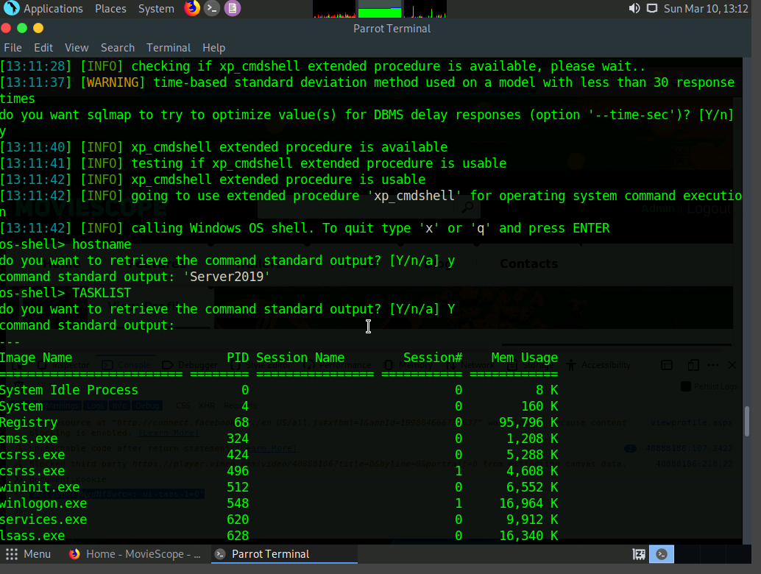
- What worked well in the lab?
The ftp process to gain access to windows and the SQL Injection.
- What parts were troublesome?
None this time I have not experience any issues while I was working in the Lab.
- Over all impression of the lab?
I was very impress with the SQL Injection and how easy was to used it, definitely I will try those methods in my personal virtual machine to see what I can get it.

